How to Make an Insect Collection Guide
What is an Insect?
Insects are invertebrate animals (no backbone) that belong to the Phylum Arthropoda, the largest phylum with over one million species. The phylum Arthropoda includes insects as well as centipedes, millipedes, spiders, mites, ticks, and scorpions, plus crustaceans such as lobster, shrimp, and crabs.

Insects have an exoskeleton to support and protect their body, three pair of jointed legs, usually two pair of wings, two antennae, and three main body parts (the head, thorax, and abdomen). The legs and wings are attached to the thorax.

An ant is a good example of insect anatomy. You can easily see the hard outer covering (exoskeleton), the head, thorax and abdomen, six jointed legs, antennae, and special mouthparts. Some ants have wings.

The class insecta is commonly divided into 20 orders, although some scientists use 30 or more orders for identification and classification of insects.
List of Classifications

Coleoptera: Beetles that have biting mouthparts and hard forewings. This is the largest order (ladybugs, fireflies, and thousands of other beetles).

Collembola: Small insects with no wings and long legs for jumping (springtails).

Dermaptera: Insects with biting mouthparts and long antennae (earwigs).

Dictyoptera: Insects that lay eggs in enclosed capsules (roaches, mantids, walking sticks).

Diptera: Insects with two wings and compound eyes. Mouthparts may be the sucking type (mosquitoes) or lapping type (house flies).

Ephemeroptera: The most primitive winged insect (mayflies).

Hemiptera: Insects with unusual heads (true bugs, assassin bug, water strider).

Homoptera: Insects with piercing, sucking mouthparts (cicadas, aphids).

Hymenoptera: Insects with four wings, long legs, and compound eyes (ants, bees, wasps).

Isoptera: Both the front and hind wings are about the same size (termites).

Lepidoptera: The wings of these insects are covered with small scales. Most have sucking mouthparts (butterflies, moths).

Neuroptera: Insects with large membranous wings with a dense network of veins (lacewings, antlions).

Odonata: Insects with two pairs of wings and biting mouthparts. Their compound eyes cover most of the head (dragonflies).

Orthoptera: All move with great agility. The wings fold over the body when not in use (grasshoppers, crickets).

Plecoptera: Insects that are flat with biting mouthparts (stoneflies).

Protura: Primitive insects with no eyes or wings.

Psocoptera: Small insects with long antennae and biting mouthparts (book lice).

Siphnoptera: Insects with long legs for jumping and sucking mouthparts (fleas).

Thysanura: Insects with soft, flat bodies (bristletails, silverfish).

Trichoptera: Insects with long antennae and legs. They have hairs on their wings (caddisflies).

Classification Keys with and without pictures are available online and in reference books.
Why Collect and Study Insects?
The study of insects is called entomology. Entomology is an important branch of science since insects affect humans in numerous ways. Insects can be pests, beneficial, or neutral. Many insects are beneficial to humans. They pollinate plants, keep other insects under control, and break down dead plants and animals. Some insects produce food, such as honey, or are eaten by animals and humans in many parts of the world, providing a good source of protein. Insects also produce important products like silk. In forensics, insects are used to determine the time and place where a human has died. Insects can be used for natural pest control, reducing the need for chemical insecticides. Gardening catalogs often offer live insects for biological control, such as praying mantises and ladybird beetles.

Insects can also be pests, destroying crops intended for human or animal food. Bees and wasps can sting humans. If a person is allergic, the sting can be fatal. Other insects are disease carriers. Millions of people worldwide die each year from diseases like malaria, which is carried by mosquitoes. Insects also carry West Nile virus, encephalitis, sleeping sickness, yellow fever, dog heartworm, and many other diseases and parasites.

Insects can be neutral, which means they are not pests or beneficial to humans. At the very least, insects provide food for many animals.

Many children are fascinated by insects. They love to take their “bug jars” and collect insects to study their habitats, feeding methods, and movement. Insects can be found almost everywhere on earth, from the arid deserts to the frozen tundra, they have adapted to a particular habitat and food sources.

Entomology gives the collector an interesting hobby, and allows close interaction with nature. The completed collection is something to be proud of. Others will view your collection and appreciate the hard work you put into it. In addition, your collection is valuable as a means for scientific study.

The collection shows diversity of insects and variations of species. By creating an insect collection, you learn the names of many insects, which insects are common in your area, and how to classify them into groups.

Many people collect insects like beetles, butterflies, and moths for their beauty and unusual characteristics. History shows that insects were studied by people as far back as the ancient Egyptians. Insect collection was a very popular hobby in previous centuries. Many of those collections have been used by scientists to show change in species over time.

An insect collection can be started by anyone and does not require special training. Simple materials are used to collect insects.

Since insects live almost everywhere, you should collect your insects from a variety of habitats. Be sure to take notes about location, movement, description, and behavior of the insects you observe. Drawings will help you remember details about the insects. Photographs are useful to show details of the insect in its habitat. After your insects are preserved, you will be able to make even more detailed drawings.
How to Make an Insect Collection

Patience is necessary for collecting insects. You can learn a great deal from careful observation.
Tools Needed for Collecting and Identifying Insects
The basic tools needed to collect, prepare, and maintain specimens of most insect orders are:

- 12” diameter insect net
- Insect box
- Two killing jars and ethyl acetate
- Forceps
- Spreading board for winged insects like butterflies
- Pinning block
- Pins
- Glassine envelopes
- Labels
- Fumigant
- 4X folding magnifier
- Pen

Other helpful materials are a notebook, magnifying bug boxes, collecting jars, containers, and plastic bags. A microscope will help you see minute details. A camera is useful for photographing insects in their habitats. Insect display boxes will house and protect your collection. Reference books and keys will help with identification. Numerous resources are available on the internet. Some references are listed at the end of this guide.

To find a particular insect, you need to know where it lives. Gardens, ponds, rotting logs, fields, forests, and swamps are good places to find a variety of insects. Try collecting at different times of day and in different seasons. Moths are easier to find at night, often around porch lights. Beetles and other insects are also attracted to light. Be aware of your surroundings to avoid unnecessary injury by harmful insects, spiders, snakes, and other animals.
Where Are Insect Found?

Reference books and field guides are good sources of information about where insects live and what they look like.

Because there are millions of species of insects and they reproduce rapidly, you don’t need to worry about depleting the population. Only a few insects are on the endangered species list. Once you research information about these insects, you can avoid collecting them.

Take you notebook and pen with you when collecting. Write the date you found the insect and where it was found. Add notes about appearance, behavior, and habitat. Drawings will help you remember details. Photographs can be used to give you important information to use when you identify your catch.

Insects such as bees, butterflies, and beetles are commonly found of flowers. They are fairly easy to catch while they are feeding on nectar.

Stems and leaves of plants are used by insects for food and shelter. Caterpillars of moths and butterflies are easier to find if you know what kind of plants they eat. For example, Monarch butterflies lay their eggs on milkweed leaves. Look for leaves that have evidence of chewing. Some insects may look like the plant they live on, an excellent use of camouflage.

Some insects spend most of their time flying in the air, such as butterflies, moths, dragonflies, and flies. Because they move so quickly, they may be difficult to catch.

Insects that burrow or dig are often found in the soil or leaf litter. When looking at leaves, be sure to turn the leaf over. The underside is usually cooler and wetter than the side exposed to the sun.

There are many types of aquatic insects in ponds. Some insects swim on top of the water, such as backswimmers and water boatmen. Water striders skate across the surface of the pond. Dragonflies are usually found near water. Aquatic insect larvae can be found in the mud at the bottom of the pond, or attached to plants and rocks.

Collecting Methods:
When searching and hand picking, observe the insect in its habitat. Collect it carefully using your fingers or forceps. If you carefully sneak up on an insect, you will have better luck catching it.

When using an insect net, don’t just wildly swing your net and hope to capture something. Carefully approach your subject, drop the net over the insect, then rotate the handle to fold the net over the rim, preventing the insect from escaping. If you are trying to catch a flying insect on the ground, cover it with the open net, then pull the tip of the net up to give the insect room to fly inside the net. Once the insect flies up in the net, hold the net closed with your fingers.

Your net can also be used to sweep vegetation. Caterpillars and leaf-eating insects can be captured using this method.

Place a sheet or large piece of cloth under some vegetation. Hit the plants with a stick. Some of the insects and larvae will fall on the sheet. You can pick them up with your fingers or forceps.

Leaf-eating insects can also be captured by collection the plant they live on. Put the plant and insect in your collecting container with a little water.

To isolate aquatic insects from mud, use a container or net to scoop up some mud from the bottom of the pond. Pour some of it into a shallow bottomed, light-colored pan, such as a cake pan. Spread the mud across the bottom of the pan in a thin layer. You will easily notice creatures to collect. Sometimes the mud is too thick to see anything. Add some water to the pan to thin it out. Another method is to drag your insect net through the plants in the water. You can keep the aquatic insects and larvae you find in an aquarium with the proper food.

If you are collecting in a stream, hold the net in the water with the opening facing upstream. Use a stick or your foot to stir up some of the vegetation. The insects will float downstream into your net.

Finding and raising insect larvae can be the best way to identify an insect. Collect the larvae and its food source. Allow it to develop in captivity. Be sure your container has good air circulation, food, and water. Some insects, like the cecropia moth, take many months to develop into adults from larvae. Others, like the monarch butterfly, only take a few weeks.

Butterflies and moths can be kept alive in a cage or aquarium with plants and sugar water. Add 1 tsp. of table sugar to 8 oz. or water. Pour a small amount into a shallow container, like a jar lid. The lid provides a perch for the insects while they are feeding. Replace the plants and sugar water often to keep them fresh. The adults may lay eggs on the plants. You can observe their life cycle over time.

Trapping is another method used to collect specimens. Pitfall traps are easily made. Bury an open container, such as a can or small plastic tub, in the soil so the rim is level with the ground. Insects walk by and fall into the container. They are usually unable to climb out. Check your trap often.

Pitfall traps can also contain food as bait. You need to know what kind of food the desired species will eat.
Rotting fruit will attract butterflies, flies, and beetles. Place the rotting fruit in an open container and watch for insects to come.

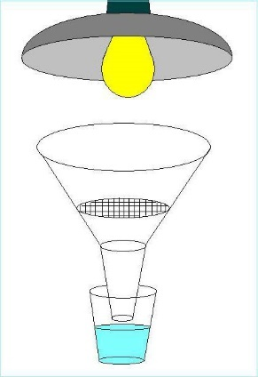
A Berlese funnel is another piece of equipment you can make easily. You will need a container for collecting the specimens, a paper cone, a piece of coarse wire mesh, alcohol, a light source, and a way to support the equipment. Keep the light far enough away from the paper cone to avoid burning it.

Half fill the collecting container with alcohol. Roll a piece of paper into a cone shape and insert the open end into the collecting jar. Place the piece of wire mesh in the cone. Scoop up soil and debris and put it on the mesh. Place a lamp over the funnel. After a short time, insects in the soil or leaf litter will try to get away from the light by traveling downward. They will fall through the mesh into the jar of alcohol.
Killing Your Specimens
After you have collected your specimens, you will need to kill them in order to mount and preserve them. A simple method of killing and preserving your insects is to place them in a container in the freezer for 24 hours.

Alternatively, a killing jar with ethyl acetate is used by many collectors. Pour a small amount of ethyl acetate into the bottom of the killing jar. Avoid breathing the vapors. Add a piece of crumpled tissue or cotton balls to the bottom of the jar. Cover the tissue or cotton balls with a piece of cardboard with holes in it. The cardboard acts like a platform to keep the insects away from the ethyl acetate liquid. Add one or two insects to the jar, close the lid tightly, and wait 30 minutes before removing them from the jar. The ethyl acetate vapors will kill the insects. Remove the dead insects with your forceps. Add two new insects to the jar. If they don’t die in one or two minutes, add a small amount of ethyl acetate to the jar.

Butterflies and moths should have a separate killing jar. Place the insects in the jar one at a time to prevent destruction of the wing scales.

Killing jars should be cleaned often to remove debris that could stick to the specimens and damage them. Use a damp tissue or paper towel to wipe out the jars.

Butterflies and moths can be placed in glassine envelopes for a short time before mounting them. The envelope helps protect the wings from damage.

Small boxes with tissue in the bottom can be used to hold small insects. Tissue works better than cotton because the insect’s legs tend to grab the cotton, which makes them difficult to remove.
Handling Specimens After Killing

Very small insects and soft-bodied insects or larvae are kept in small glass bottles or vials filled with 70% isopropyl alcohol. Each bottle should have only one insect. Labels will be added later.

In many cases you can use your fingers to handle specimens after killing. Forceps should be used to pick up butterflies and moths by their bodies to avoid damaging the wings. Stinging insects and tiny insects are picked up with forceps. Be careful not to squash your specimens.
Mounting and Preserving Specimens
Many insects are mounted using entomology pins. The pins are long, thin and rust proof. Pins range in size from very tiny 000 to heavy 7. Sizes 1, 2 & 3 are used most often.

Do not use sewing pins to mount your insects. They are too thick and too short. They also rust easily. Sewing pins can crush or otherwise damage your specimens.

Most large insects are pinned through the right side of the thorax using size 2 or 3 pins. (Some scientists prefer to pin their insects on their sides so they can see the top and bottom of the insect without picking it up.) Small insects are pinned with size 1 pins or smaller. Place insects on pins so they are horizontal to the bottom of the display box.

After inserting the pin, gently push the insect about half-way down the pin. This gives you a place to hold so you can pick up the pin without damaging the insect.
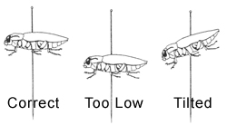
Any insect that is large enough to be supported on a pin without breaking or otherwise being distorted is pinned directly through the body. Insert the pin through the body from top to bottom. The proper place of insertion depends upon the type of insect (Figure 15). The following rules are for pinning different types of insects so that the pin is placed firmly through the heavier parts of the body without destroying important identifying characteristics.
- Bees, wasps, flies, etc. — Pin through the thorax between bases of fore wings and slightly to right of middle line (Figure A).
- True bugs — Pin through the scutellum, which is the triangular area between the bases of the wings (Figure B).
- Grasshoppers, crickets, etc. — Pin through the prothorax or “saddle” slightly to the right of the center line (Figures C and D).
- Beetles — Pin through the forepart of the right wing cover near the centerline (Figure E).
- Butterflies, moths, dragonflies, etc. — Pin through center of thorax between the bases of forewings (Figures F and G).
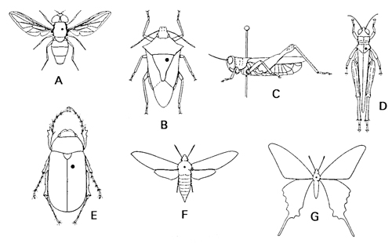

Labels will be added to the pin below the insect at a later time. A pinning block is used to position the insect and labels on the pins.

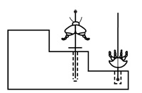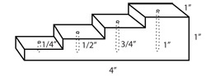

Small insects can also be mounted on “points”. Cut a thin wedge of index card. A size 2 or 3 pin is pushed through the wide end of the wedge. The pointed end is bent down. A small drop of glue or fingernail polish is placed on the pointed end and touched to the right side of the insect’s thorax.

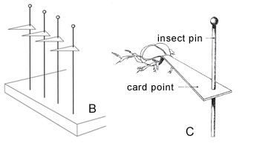

If your insects have been left in the glassine envelopes or containers so long that they are brittle, they will need to be “relaxed” or softened before pinning.

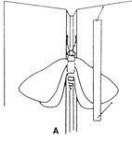
A relaxing chamber can be made from a wide-mouth jar with a lid. Put a wet piece of sponge in the bottom of the jar. Place a layer of cotton over the sponge to keep the specimen away from the water. A platform can be made from a piece of cardboard with holes in it. The lid of the jar should be lined with absorbent paper to collect condensate, so it doesn’t fall back on the specimen.

Insects can be placed in the relaxing chamber in their glassine envelopes for a few hours. Do not leave them in the jar more than 24 hours or mold will start to grow and ruin your specimen.

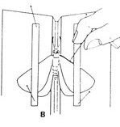
To mount butterflies and moths once they are softened, a spreading board is used to flatten the wings. The board has a groove in the middle to accept the body of the insect and flat surfaces for the wings. Antennae and legs are arranged in a natural position.

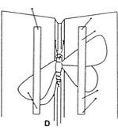
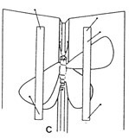
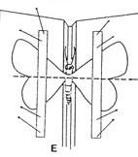
Insert an insect pin through the right side of the thorax. Place the insect on the pinning board with its body in the groove. The groove is tapered to accommodate different sized insects. Using an insect pin, carefully spread the wings open. Blowing gently on the wings is another way to separate them. Use a strip of glassine to hold the wing. Insert pins through the glassine into the spreading board. Do not pin the wing directly. When spreading the insect, be careful not to break off any legs or antennae. These are needed for proper identification. If you are unsure of your technique, practice pinning common butterflies or moths collected for this purpose before working on your other specimens.

Once the insect is dry, the wings will remain open. It takes one to two weeks for a specimen to dry completely.

Identification of the insects in your collection requires research using field glasses, reference books, and the Internet. You may also need to contact an entomologist at a university to help identify certain species.
Identifying and Labeling Your Insects

Dichotomous keys are often used for identification of insects. Many keys are available online.

Your insect must be accurately identifies before you label it. Print legibly on the first label with a fine-point permanent marker, or print labels on your computer. Write the date collected, specific place of capture, your name, and the method of collection (optional). Instead of a large label, use two or three small ones. Do not write on the back of the label. You should be able to read the labels while the insects are in their display box. Insert the pin with the insect through the label using the pinning block. A second label includes the species name, name of determiner, and year of determination.
Preserving Your Collection

You have found your specimens, researched information about them, labeled, and pinned them. Now you need to display them in your permanent collection. Special mounting boxes with glass tops are available in scientific supply catalogs. Insects on pins with their labels are pinned to the soft bottom of the box in an orderly manner. You must decide how you want to group your specimens. Do you want to mix species in the same box, or have each display box represent one species?
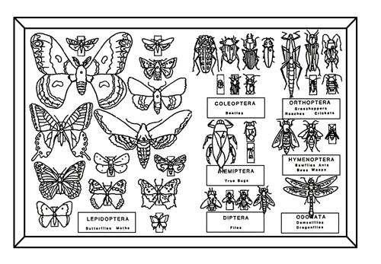

Store your collection in a dry place away from light. If it is damp, fungus will grow on your insects. Bright light will eventually fade the color of your insects. Many permanent insect collections contain a fumigant to keep out undesirable live insects that can eat your collection. Sometimes these fumigants are toxic. An alternative method for killing undesirable insects is to put your collection in the freezer for 24 hours. This should be done every few months. Freezing will kill any unwanted pests.
Books:
Suggested References and Websites
- Gibb, T. J. and C. Y. Oseto. 2006. Arthropod Collection and Identification—Laboratory and Field Techniques. 311 pp. New York, Elsevier/Academic Press.

- Borror, D.J., C.A. Triplehorn, and N. F. Johnson. 1989. An Introduction to the Study of Insects, 875 pp. Philadelphia, Sanders College Publishing.

- Eaton, Eric and Kaufman, Kenn. 2007. Kaufman Field Guide to Insects of North America (Kaufman Field Guides), 392 pp. New York, Houghton Mifflin Harcourt.

- Evans, Arthur V. 2007. National Wildlife Federation Field Guide to Insects and Spiders of North America, 496 pp. New York, Sterling

Online Resources:
- www.bijlmakers.com
- bughunter.tamu.edu
- insects.tamu.edu
- bugguide.net
- www.insectidentification.org
- www.biologyjunction.com/insect_collection.htm

There are thousands of online resources, this is just a small sampling. Most major universities have entomology departments and experts to help with identification.

