2020 Virtual Catfish Skill-a-thon and
Educational Opportunities

Species
Catfish: Channel, blue and their hybrids or subspecies and flathead

See link below to learn how to identify specific fish species in Texas.
https://tpwd.texas.gov/landwater/water/aquaticspecies/inland.phtml

Levels of Skill-a-thon Participation

Species | Tournament Level | Participation
Catfish | State-wide | Individual and/or team
 | District (4, 5, 7, 9, 10, 11) | Individual and/or team
 | Big Catfish | State individual, state team, district individual, district team

Schedule

Species | Dates | Fishing Times
Catfish | May 16-17  May 23-24  May 30-31 | Begins 8:00 am on Saturday  Ends Sunday at 3:00 pm

Location
- Fish anywhere permitted by law (freshwater, ponds, stock tanks, rivers, lakes, etc.).
- Boats are not required.
- Post entry pictures for judging on Facebook during specified dates and times.

Safety and State Fishing Regulations
- Be sure to follow all Texas regulations regarding fishing licenses, bag limits, length requirements and other rules https://tpwd.texas.gov/regulations/outdoor-annual/fishing/
- Each 4-H family entered is responsible for the safety of youth anglers during the tournaments.
Educational Opportunities
- 4-H members that join the Facebook 2020 4-H Fishing group, will have the opportunity to view videos from Texas A&M AgriLife Extension and Texas Parks and Wildlife on using fishing gear, selecting lures and other topics of interest.

- Schedule of Educational Opportunities
  - Monday: Fishing Techniques and Tips
  - Tuesday: Cooking with Catfish: Healthy Food Demo and Recipe
  - Wednesday: A Visit with the Game Warden
  - Thursday: Fishing Safety
  - Friday: Fun Facts, Trivia and 10 for 10 Catfish Game
  - Saturday-Sunday: Fishing Skill-a-thon

Entry Requirements
  - Register on 4-H Connect beginning April 28, 2020 at https://texas.4honline.com
- After registering on 4-H Connect, participants must join the Facebook 4-H Fishing group by clicking here or going to https://www.facebook.com/groups/1202432833284039/
at least 2 days before the skill-a-thon begins.

Entry Fees
  - 4-H youth, including Clover Kids, may enter the statewide, district and big catfish skill-a-thons. Participation at the state level is REQUIRED (individual and/or team).
  - Teams are comprised of 3 or 4 members of any 4-H age division (mixed teams are permitted).

REQUIRED ENTRY
State Events - $25 per individual per event

    - State individual – Exhibit your skills against all entered 4-H’ers across the state.
    - State team – Exhibit your skills as a 3-4 member team against all entered 4-H’ers across the state.

OPTIONAL ENTRY
District Events - $10 per individual per event

    - District individual – Exhibit your skills against other registered district participants for separate awards and prizes.
    - District team – Exhibit your skills as a 3-4 member team against other registered district participants for separate awards and prizes.

OPTIONAL ENTRY
Big Catfish Events - $5 per individual per event

    - State Big Catfish individual – Exhibit your skills against all entered 4-H’ers across the state for the biggest catfish.
    - State Big Catfish team – Exhibit your skills as a 3-4 member team against all entered 4-H’ers across the state for the biggest catfish.
    - District Big Catfish individual – Exhibit your skills against all entered district participants for the biggest catfish.
    - District Big Catfish team - Exhibit your skills as a 3-4 member team against other registered district participants for the biggest catfish.

Registration Deadlines
  - Entry to 4-H Connect is due by May 13, 2020 to participate in the May 16th skill-a-thon. Only those registered on 4-H Connect by the deadline will be eligible to participate.
  - 4-H Connect will reopen on May 18th for registration for the May 23rd skill-a-thon (you only need to register again, if you did not register for the initial skill-a-thon).
  - 4-H Connect will reopen on May 25th for registration for the May 30th skill-a-thon (you only need to register again, if you did not register for the initial or second skill-a-thon).

Recognition
- Presentation of awards will take place at county level after June 12, 2020.
  - 1st – 3rd places will be presented a rosette and a prize to be determined by 4-H Fishing committee.
- Entry via 4-H Connect gives permission to the District office to use the participant’s name and photograph as needed for marketing and promotion purposes.

Skill-a-thon and Participation Rules
Catfish Skill-a-thon (individual and/or event)
- Event Dates: May 16-17, 23-24 and 30-31.
- Times: 8:00 a.m. on Saturday through 3:00 p.m. on Sunday - postings before or after times will be disqualified.
- Team: A team is comprised of a minimum of 3 members and a maximum of 4 members.
- Catfish Species for Judging: Channel, blue and their hybrids and subspecies, and flathead.
- Posting Limits: Catch up to a daily bag limit of catfish during event hours. No more than 6 catfish should be posted. Within the 6 posted, only 1 flathead may be posted, if caught. See minimum length requirements below:
  - Channel, blue and their hybrids and subspecies daily bag limit: 5 in any combination, with a minimum length of 12 inches.
  - Flathead daily bag limit: 1 with a minimum length of 18 inches.

- Virtual Participation Criteria:
  - Photograph of fish and card must be posted to the Facebook group page (2020 4-H Fishing) between 8:00 am on Saturday through 3:00 pm on Sunday. You must receive approval to join this group before the skill-a-thon begins. Photographs posted before or after skill-a-thon times will be non-scoring. Note: This may mean that you change locations before time is up to ensure you have internet service.
  - Photograph must be able to be seen and measurement on board must also be legible. You may hold your fish on the board, just be sure to not cover the mouth and tail with anything that blocks these views.
Fish measuring smaller than 24 inches
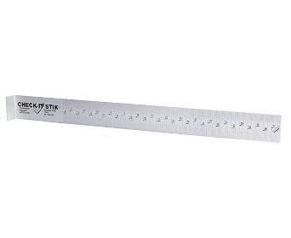
  - Fish measuring smaller than 24 inches must be photographed laying on a Check-It-Stik brand measuring board in addition to a completed note card or the optional form below. Check-It-Stiks can be purchased at Academy, on-line and at other fishing gear stores.
  - Mouth of fish must be closed, touching the start of the bump board at the zero-inch mark and tail pinched.
  - Fish must be laying with its left side up and in view of photograph. Fish photographed on right side will be non-scoring.
Check-It-Stik Brand
  - If measurement cannot be read from photograph, the entry
will be disqualified. See example below:
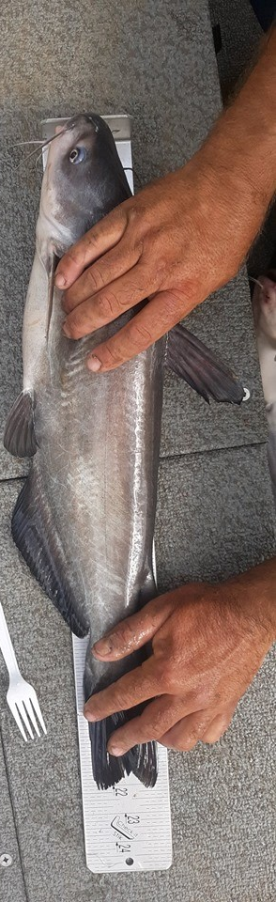

Fish measuring longer than 24 inches
  - Fish larger than 24 inches should be measured on a 6-foot long 2x4 or 2x6 piece of wood. Lay the fish, left side up, on the board and mark its length with a pen/pencil (see example below). Then measure from the beginning of the board to the mark using a tape measure or a yard stick in addition to a completed note card or the optional form below.
  - Adding a close-up photo of the tail and measurement if longer than the check-it-stik is recommended. If a tail picture with ending measurement is posted too, card needs to be in the picture.

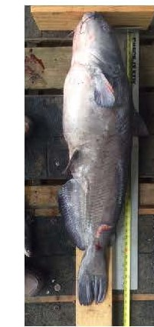
  - You will be given an eight letter/digit code for each event to display on an index card, or use the preprinted form below, with your fish photograph. The code will be revealed one hour before the skill-a-thon begins. It will be posted to the Facebook 2020 4-H Fishing group that morning.

  - Card must be in photograph with fish on Check-it-Stik or piece of 2x4 or 2x6, depending upon the length of the fish (see above length requirements).
  - Index card must have District, County, youth name, fish number, and eight-digit code. Cards that cannot be read will be disqualified. Suggestion: Place each card in a ziplock bag so it remains dry and ink does not run.
  - If participating in a team, place the name of angler that caught the fish on the top line (Team Member #1).

- Optional Big Catfish Skill-a-thon:
- Youth entered in the Optional Big Catfish skill-a-thon will compete individually against other 4-H anglers across the state. Must be entered in 4-H Connect before start of skill-a-thon.
- Awards/prizes will be given to the top 3 big catfish from entire skill-a-thon.
  - Length is measured in inches from mouth to tip of tail, not the fork.

Please print – must be legible!

District ________________ County _________________________

Fish Number: __________

8-digit code: _________________________
(posted 1 hour before skill-a-thon on FB 2020 4-H Fishing group page)

Individual Angler Name: _______________________________________________

(Complete below if registered as a team)

Angler Name 1: _____________________________________________________

Angler Name 2: _____________________________________________________

Angler Name 3: _____________________________________________________

Angler Name 4: _____________________________________________________

