2020 District 5 Roundup Contest Information

Date
Saturday, May 2, 2020

Location
Panola College, 1109 W. Panola Street, Carthage, Texas 75633

Entry Requirements
  - Enter individually on 4-H Connect beginning February 26, 2020 at https://texas.4honline.com
  - Contest Fee - $10 per contestant per entry
- Late Entry Fee - $25 per contestant

Roundup Contests

  - Educational Presentations (Individual or Team event) – see contest information for categories. When registering, both team members must be listed in 4-H Connect.
  - Public Speaking (Individual event)
  - Share the Fun (Individual or Team event) – see contest information for categories. When registering, ALL team members must be listed in 4-H Connect.
  - Leaders 4 Life (Team event) - When registering, ALL team members must be listed in 4-H Connect.
  - Livestock Quiz Bowl (Team event) - When registering, ALL team members must be listed in 4-H Connect.
  - Horse Quiz Bowl (Team event) - When registering, ALL team members must be listed in 4-H Connect.

Come-and-Go Contests

  - Photography Judging (Individual or Team event) - When registering, ALL team members must be listed in 4-H Connect.
  - Agriculture Product Identification (Individual or Team event) - When registering, ALL team members must be listed in 4-H Connect.
  - Horticulture Identification (Individual event)

District Deadlines
  - Registration on 4-H Connect by April 8, 2020
  - Late entry – April 10-14, 2020 (late fees apply)

Entry Divisions (grade by August 31, 2019)
  - Junior Grades 3, 4, and 5
  - Intermediate Grades 6, 7, and 8
  - Senior Grades 9, 10, 11 and 12

Special Accommodations
- Any competitor who requires auxiliary aids or special accommodations must contact the District office at least 2 weeks before the competition or note such needs when registering on 4-H Connect.

Overall Schedule
- Schedule may be modified based upon number of Roundup contestants.
- Specific times for each contest will be sent to county Extension agents ONE week before event. Final schedule will be posted on the district website at D54-H.tamu.edu and on the district Facebook page at District 5 Texas 4-H

Come-and-Go Contest Schedule (Ag Product ID, Horticulture ID, Photography Judging)
- The Come-and-Go contest rooms will open at 8:00 a.m. and close at 11:30 a.m. Contestants participating in Roundup contests will need to complete their Come-and-Go contests before checking-in for Roundup.
- If participating in multiple contests, it is recommended that contestants complete their Come-and-Go events (8:00 to 9:00 am) before continuing to the longer Roundup contests.

Roundup Schedule (Speaking, Quiz Bowl, Share-the-Fun, Leaders 4 Life)
- Roundup contestants are scheduled to check-in to their judging rooms between 9:00 and 9:30 a.m.
- Share-the-Fun contestants may unload their props backstage, during check-in time, until needed for judging.
- Contestant orientation will begin at 9:30 a.m. in each judging room.
- Judging will begin promptly at 9:45 a.m. No one will be permitted into the judging rooms after 9:45 a.m.

Questions at Contest
  - Please see help desk attendant located in the Matthews Foundation Student Center building.
  - Committee members will be wearing a 4-H lanyard and can help provide directions.
  - Please provide feedback for 4-H contests by completing a short survey (paper or QR code) located at the Help Desk. In addition, a survey link will be sent with the final schedule to complete electronically.

Awards
- Presentation of awards for each Roundup contest will be held in each judging room following tabulation of results.
- Those placing in a come-and-go contest will receive awards and prizes at their county Extension office.
- Placings for come-and-go contests will be posted at the Help Desk once tabulation is complete.
- 1st – 3rd places will be presented a rosette and a prize to be determined by committee.
- Entry via 4-H Connect gives permission to the District office to use the participant’s name and/or photograph as needed for marketing and promotion purposes.

Scoring Criteria
  - Rankings, judges’ comments and other correspondence will be forwarded to the contestant’s county Extension office. Please allow up to three weeks for processing.
  - Seniors (individual or team) must score an 80 or above to participate in the state Texas 4-H Roundup, regardless of contest placing.

Qualifying for State Roundup
  - The top three Senior age division teams (grades 9-12) at the District-level Roundup will advance to state, if they meet scoring criteria.
  - Exceptions:
    - The top two Share the Fun entries will advance to state, if they meet scoring criteria.
  - Horticulture Identification is a District 5 contest only and there is no advancement to state.
  - Agriculture Product Identification is an invitational contest.
  - The Texas 4-H Roundup contestant paperwork is available online at
https://texas4-h.tamu.edu/events/roundup/

educational presentations
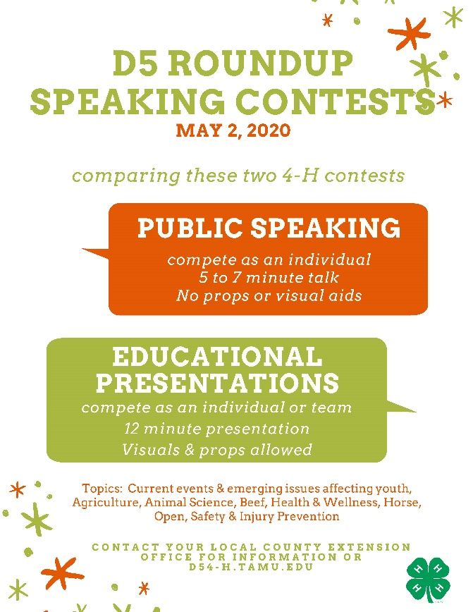
An educational presentation is a fun way to share information with others about your 4-H project. You can give an educational presentation by yourself or with one of your 4-H friends.
Entry: Enter as an individual or a team that is comprised of two members of the same 4-H age division.
Time Limits
- A time limit of 12 minutes will be allowed for each presentation.
- A penalty of 2 points per minute over time will be deducted from final score.
Topic Subject: All presentations should address current or emerging issues related to the topic category.
Topic Categories
- Agriculture Technology and Farm Safety - Current or future subjects that addresses biotechnology, biogenetics, bioengineering, mechanical engineering, or farm safety. Use of technology, research, laser, satellites or advancements made in agricultural practices through technology, computer systems, or cutting-edge ideas.

- Animal Science - Current or future subjects that addresses any aspects of the dairy, poultry, sheep, goat, swine, or specialty animal industries such as embryo transfer and invitro-fertilization. Beef related presentations would fall under the beef category.

- Beef - Current or future subjects that addresses reproductive technologies, nutritional management, health, breeding and genetic considerations, behavior, beef carcasses and end-products, production costs, general management aspects, or cattle marketing. Presentations may target cow-calf, stocker, or feedlot industry sectors.

- Health & Wellness - Presentations should focus on healthy lifestyles, prevention and wellness, not illness/treatment. It is suggested that project experiences in this area include topics aimed at youth health, wellness and prevention and that the educational presentations be shared with other youth groups in the community to promote healthy lifestyles. All presentations must be supported by science-based and current medical/health journal articles (e.g., Journal of the American Medical Association, Annuals of Internal Guide Medicine) or research-based websites. No .com resources are allowed. Suggested presentation topics: Increasing physical activity, tobacco prevention, alcohol prevention, sun safety, preventing the spread of the cold and flu, sleep or reducing stress.
- Horse - Presentation is to cover the theory and/or practical skills learned in the 4-H horse project and should be appropriate for presentation at a 4-H club meeting. After hearing the presentation, the audience should be able to put information into practice to improve their production, management, training, or horse use/knowledge and/or skills.
- Open - Youth will relate information to skills learned in a project in which the 4-H member has been involved. Make sure your presentation is not better suited for another category.
- Open: Agriculture and Natural Resources - Youth will relate information to knowledge or skills learned in the field of Agriculture and Natural Resources. Topics include: agronomy/crop production, farm and ranch economics, horticulture, meat science, shooting sports related fields or other ANR field of study.
- Open: Family and Community Health - Youth will relate information to knowledge or skills learned in the field of Family Community Health. Topics include: consumer life skills, food and nutrition, housing and home environment, or other FCH field of study. Health related topics, which could include such things as increasing physical activity, tobacco and alcohol prevention, sun safety, preventing spread of colds and flu, sleep, and reducing stress, should compete under Health &Wellness educational presentation.
- Promote 4-H - The purpose of this contest is to encourage 4-H members to develop promotion and marketing skills as they market and interpret 4-H through various types of media and presentations, increase the promotion of 4-H to non-4-H audiences in Texas, and increase the number of people who join and support the 4-H program. The 4-H promotion should convey a contemporary image of 4-H in a changing society. Promotional methods include: radio, television, illustrated talks, method demonstrations, newspaper, posters, projected images, exhibits, photographs, slide/tape presentations, puppets, PSA’s, speeches, drama, skits, videos, computer programs, etc.
- Safety & Injury Prevention - Youth will relate information to safe equipment designs and safe procedures or methods associated with the prevention of accidents in work, home, or recreational environments. Topics may include accident prevention when operating motor vehicles, boats, home, farm or yard machinery. Also included are safety topics on handling chemicals and animals and prevention of accidents relative to falls, fire, electricity, hunting and natural disasters. Suggested presentation topics: drinking and driving, distracted driving, personal safety, ATV safety, agri-terrorism, general farm safety, pesticide safety, natural disasters (flooding, tornadoes, hurricanes, drought, etc.).
Accuracy of Information/Resources
- With the computer and internet being used heavily in educational presentations, 4-H members must know the difference between research and non-research-based information.
- Contestants are required to use information that is factual and can be supported through adequate documentation. Examples of such websites are federal, state, and local governments, independent research sites, and Texas A&M AgriLife Extension Service websites. Internet information that is questionable includes personal documentation sites, chat rooms, message boards, etc.
- 4-H members must prepare a list of references (i.e. bibliography, works cited) for their presentation.
Visuals
- The use of charts, photographs, computer graphics/programs, and other visual materials are permitted. Visuals should contribute to the presentation. Each presentation is an example of the participant’s ability to communicate an idea.
- No firearms, weapons, fireworks, open flamed burners, live ammunition or live animals are allowed to be used by a contestant in any Roundup contest. However, posters and pictures of such items are allowed and encouraged.
Video, Audio and Display Equipment
- Contest officials will provide laptops, screens, extension cords and projectors.
- Youth should have all presentations in some form of Microsoft Office (PowerPoint, Word, or Excel).
- All fonts used must be true type. These fonts specifically include Arial and Times New Roman.
- If contestants decide to use any other program or fonts, they will be responsible for bringing all equipment that is compatible with their presentation.
Scoring
- The 4-H Educational Presentation Score Sheet, version 2019, will be used by contest judges in scoring educational presentations regardless of presentation style (method demonstration, illustrated talk, or speech). All score sheets are on the Texas 4-H website.
Resources
- See the publication “What is an Educational Presentation” for additional information on this contest at http://texas4-h.tamu.edu/wp-content/uploads/Educational_Presentations_Information.pdf

public speaking
Interested in presenting a speech on current events and issues? 4-H members have the opportunity to present a 5- to 7-minute talk suitable as a platform speech or radio broadcast. The presentation should serve to persuade others regarding a particular issue or concern.
Entry: Enter as an individual.
Time limits
- A time limit of 7 minutes will be allowed for each presentation.
- A penalty of 2 points per minute over time will be deducted from final score.
Suggested presentation topics
- Current events, youth issues, or other topics related to youth.
- Topic resources: Print media (e.g. newspapers, magazines, scholarly journals), broadcast media (e.g. television, cable, radio), or E-media (email, internet, websites).
- Contestants should be prepared to answer questions concerning the subject matter of their presentation following their conclusion.
Visual aids and props may not be used.

Scoring
- The 4-H Educational Presentation Score Sheet, version 2019, will be used by contest judges in scoring educational presentations regardless of presentation style (method demonstration, illustrated talk, or speech). All score sheets are on the Texas 4-H website.
Resources
- See the publication “What is an Educational Presentation” for additional information on this contest at http://texas4-h.tamu.edu/wp-content/uploads/Educational_Presentations_Information.pdf

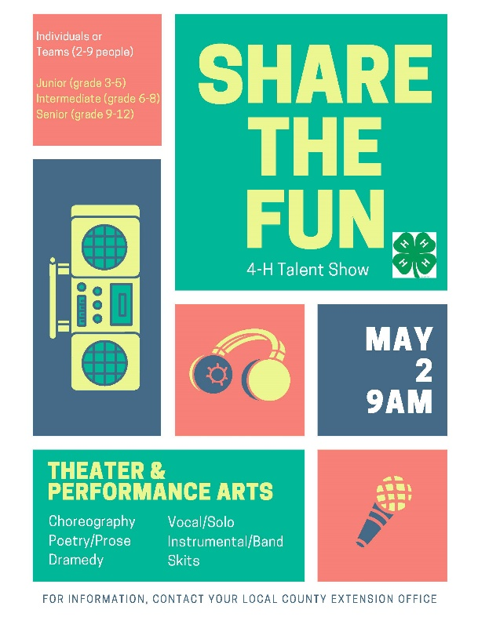
Share-the-Fun is a competitive event related to the Theater and Performance Arts project. 4-H members have the chance to develop a spirit of cooperation with their fellow 4-H members; develop self-confidence through public performance; stimulate interest in broad-based recreation in 4-H clubs; encourage 4-H members to discover and develop their talents and to grow socially, culturally, and further develop leadership skills.
share-the-fun
Entry
- Enter as an individual and/or a team of 2 to 9 members.
- Teams are made up of individuals in the same age division (Junior, Intermediate or Senior).

Categories
- Choreographed Routines
  - The act requires choreography and can be demonstrated through twirling, pom-pom squad routines, jump rope teams, basketball dribbling exhibitions, or dance (jazz, tap, country & western, ballroom, etc.).
  - Sign language presentations to music have been added to choreographed routines. However, if a participant is SINGING and SIGNING, this entry should be entered in the Vocal Category.
  - No speaking to form a skit or story line.
  - All 4-H members entered in the category must be a part of the act.
  - Acts may use recorded music on CD or digital music player but may not use an accompanist.
  - Judged on material chosen, talent, creativity, showmanship, costuming, and material chosen.

- Dramedy
  - This is an acting category. A dramedy (also known as a comedy-drama or comedic drama) is an act that combines elements of comedy and drama, having both humorous and sometimes serious content.
  - Acts cannot incorporate 4-H related material or theme. (Otherwise, it would be categorized as Celebrate 4-H).
  - Skits can be currently available scripts, original material, or a combination of the two.
  - Humor and creativity are encouraged, but the degradation of any individual or organization is not permitted.
  - May incorporate music, vocal selections, and/or choreographed routines, but these aspects cannot be more than half of the performance.
  - Judged on material chosen, talent, creativity, showmanship, costumes and props.

- Poetry/Prose
  - Acts which showcase poetry or prose are required.
  - The act may NOT incorporate vocal, musical, and/or choreographed routine.
  - This category does not require 4-H related material, however, if an original poem or prose piece showcasing 4-H is written, this would be acceptable.
  - Every 4-H member entered in the category must be a part of the performance on stage.
  - All material must be memorized. No script may be used during the performance.
  - Judged on material chosen, message, talent, presentation style, props/costuming.
  - Definitions - Poetry is generally characterized by structured meter and rhyme that tells a story or provides a message to the reader. Prose is distinguished from poetry by its greater variety of rhythm and its closer resemblance to the patterns of everyday speech. Another description might be an excerpt from a larger piece such as a play or book.

- Vocal
  - Vocal presentation may be done a cappella or with an accompaniment CD, iPod, or other mp3 player.
  - No accompanist will be allowed for this category.
  - All members in the act must be singing.
  - No lip sync will be allowed.
  - Contestants may not present skits, poetry or other speaking during the act. They may, however, move around the stage and incorporate choreography with their presentation for the purpose of enhancing their showmanship.
  - Sign language may be added to enhance the performance, but entries that strictly showcase sign language without vocal presentation are not permitted in this category, they must be entered in choreographed routines.
  - Judged on talent, showmanship, vocal presentation, and material chosen.

- Celebrate 4-H
  - May be a 4-H based story line, promoting 4-H, community service, a project or activity.
  - This category may also address a specific youth issue and present ways in which this issue can be addressed through 4-H efforts.
  - May incorporate music, vocal selections, and/or choreographed routines but these aspects cannot be more than half of the performance.
  - Skits can be humorous, creative but cannot make fun of others or the 4-H program.
  - All 4-H members entered in the category must be a part of the act.
  - Judged on material chosen, talent, creativity, showmanship, costumes and props.

- Musical/Instrumental
  - Musical presentation may be musical instruments accompanied by background recorded music or an instrumental performance only.
  - No accompanist will be allowed.
  - Participants may not sing or incorporate a skit, poetry, prose, or choreography with their act.
  - Judged on talent, showmanship, musical presentation, and material chosen.

- Solo/Band Performance
  - This act incorporates a combination of vocal and musical/instrumental talents.
  - Acts that are vocal only or musical/instrumental only are not to be entered in this category.
  - All 4-H members entered in the category must be a part of the act by playing a musical instrument, singing, or both (solo performance must play an instrument and sing).
  - Participants MUST incorporate singing in the acts, but cannot incorporate skits, poetry, or prose. They may, however, move around the stage and incorporate choreography with their presentation for the purpose of enhancing their showmanship.
  - Judged on talent, showmanship, musical presentation, vocal presentation when applicable, and material chosen.

Time Limits
- Contestants may use up to four (4) minutes for set-up and break down; maximum of six (6) minutes for presentation for a total of ten (10) minutes per act.

Scoring
- A penalty of five (5) points per minute or part of a minute over the time limits allowed will be deducted from the total score.
Presentation Material
- Participants must compete with the same material at all levels of competition–county, district, and state. For example, you cannot choose one song for your act and then change songs between District and State.
- Acts may fine-tune performances based on critiques from county and district judging, but changing material completely is prohibited.
Props
- Props utilized must be able to go through doors that are 6 ft. wide and 7 ft. tall.
- The following materials may not be used in any category: talcum powder/baby powder, flour, pies, food, water, oil, loose feathers, flower petals, hay, straw, helium balloons, glitter, sand, confetti, open flames or other substances which are hard to clean up, may cause damage, or be dangerous to participants.
- No roller skates, shoes with spikes, cleats, motorized vehicles or live animals will be allowed.
Introduction of the Act
- Contestants do not need to introduce themselves. At Roundup, each act will be introduced individually, immediately prior to their performance by the announcer.
- The introduction/description will be submitted as part of the Required Information Form that is due prior to Roundup. Anything that needs to be said should be included in the introduction to be read by the announcers; however, if you choose to add information, it will count against your performance time and may confuse judges depending on the delivery method.
Adult Assistance – Set-up
- Only adult coaches and/or agents will be allowed backstage, in the vicinity of the storage area of props, and to assist the 4-H members with set-up and break down of props and equipment. 4-H members or other youth who are not a part of the team will not be allowed to assist with set-up or take down.
- One person should be designated by the group to work with the stage manager when it is your turn to set up for your performance. This person should know exact locations for all equipment, props, etc. on stage and be able to give clear instructions.
Adult Assistance - Performance
- During a performance adult coaches may give cues for music backstage and help with costume/prop changes backstage. They are NOT allowed to participate in any other form in the act while the act is going on. Any voices heard during the performance from backstage must be either a participant OR a recorded voice.

Accompanist
- NO Accompanist will be permitted for any category.
- If music is required, it must be submitted on the Required Information Form or performed by the contestant. See Category Descriptions for specific rules for each category.
Audience
- Parents, family and friends are welcome to view the Share-the-Fun contest as a member of the audience, as space permits in the auditorium.

Practice/Warm Up
- There will NOT be a location for warm-up or practice. 4-H members should rehearse and come prepared to present a top-notch performance. The Roundup schedule does not allow time for practice.
- A brief amount of time will be permitted to view stage, backstage, etc. following participant orientation.

Dressing Rooms
- Male and female dressing rooms will be provided in the Martin Auditorium building.

Required Information Form
- Share-the-Fun contestants must complete and submit the REQUIRED Online Information Form by April 8 to their county Extension agent. This form can be found at the following link: https://d54-h.tamu.edu/2017-18-contests-events/2019-2020-contests-and-events/2019-20-roundup-district/

Music
- All music must be uploaded on the Required Information Form online by the deadline prior to Roundup. The music must be in .wav or .mp3 format. You may upload multiple files.
- Each audio file will need to be clearly labeled with the Category, County, and Name of individual or team.

Stage Contest Area
- Stage - approximately 32 ½’ wide and 23’deep and raised
- Piano
- Projector screen (may bring own projector; projector will NOT be provided)
- Stool
- Table
- Chair
- Theatrical lighting; no spotlights
- Microphones and inputs based upon individual need
Qualifying for State Roundup
- The Senior age division, first and second place winners, from each category at District will qualify for Texas 4-H Roundup.

This contest provides youth the ability to further their knowledge and skills when evaluating agricultural products grown in Texas.
agriculture product identification
Entry
- Enter as an individual and/or a team of 3 to 4 members.
- Teams are made up of individuals in the same age division (Junior, Intermediate or Senior).

Electronic Devices
  - No electronic devices, calculators, or jewelry (except for medically required) is allowed in contest area. This includes cell phones, smart watches, or other communication devices.

Contest
- This contest is a come and go event with small groups permitted into the contest room every 20 minutes beginning at 8:00 a.m. The last group that will be permitted to participate in the contest will begin at 11:30 a.m.
- Contestants will be provided a scantron form, pencil and clip board to respond to questions.
- 20 Texas agricultural products from categories such as protein, fruits, vegetables and nuts, grains, and fibers are selected. These selected products are exhibited at separate stations. Contestants choose the correct identification of each product from four possible answers.
- Following the product identification, each station has one multiple-choice question pertaining to the product on display. Questions can be general to the industry that produced the product, (i.e. Texas’ national ranking, economic impact to Texas, general nutrition content, region of production) and specific to the individual product that is on display (i.e. cooking method, use, growing season, specific nutrition of the cut or variety).
- Only registered contestants, committee members and judges are permitted in the judging room.
- Contestants may not leave once the contest has started unless permission is given by the contest superintendent. Contestants should not separate themselves from the class on which their group is working. Contestants should not in any way willfully obstruct the work of another contestant.
- While the contest is in progress, there shall be no talking or any other type of communication between contestants. If a contestant has a question once the contest begins, please direct that question to the assigned group leader or the contest superintendent.
Time Limits: Contestants are given 30 seconds at each station to answer both questions on their scantron.
Scoring
- Contestants will receive five (5) points for each product that is correctly identified and five (5) points for each question that is correctly answered. However, for points to be awarded on questions pertaining directly to the product displayed, the product must be correctly identified. Points will be awarded for correct answers to questions general to the industry regardless of the product being correctly identified. A total of 200 points is possible for each individual. Team scores can reach 600 points (high three scores counted).
- Five (5) stations will be selected as tie breakers in advance of the contest. Teams with the highest cumulative scores at these five stations will win any ties.
- Scantrons will be scored at the close of the contest. Contest placings will be posted at the Help Desk in the Matthews Foundation Student Center building.
- Awards and prizes will be sent to the county Extension offices for pick-up by participants.
Study Guide: You will find a list of resources and study guide to download on the 4-H website at http://texas4-h.tamu.edu/wp-content/uploads/agproductidguide.pdf

Horticulture samples will be selected and exhibited at separate stations from a predetermined list of 50 plants (see study guide).
horticulture identification
Entry: Enter as an individual.

Electronic Devices
  - No electronic devices, calculators, or jewelry (except for medically required) is allowed in contest area. This includes cell phones, smart watches, or other communication devices.

Contest
- Horticulture specimens from the attached predetermined list of ornamentals, flowers, trees, shrubs, ground cover, vines, tropical, perennials, and annuals are selected for identification. These selected specimens are exhibited at separate stations either as an actual sample or a pictorial representation.
- Contestants must identify the following number of specimens based upon age division:
  - Junior 15
  - Intermediate 20
  - Senior 30
- This contest is a come and go event with small groups permitted into the contest room every 20 minutes beginning at 8:00 a.m. The last group that will be permitted to participate in the contest will begin at 11:30 a.m.
- Contestants will be provided an answer form, pencil and clip board to respond to questions.
- Only registered contestants, committee members and judges are permitted in the judging room.
- Contestants may not leave once the contest has started unless permission is given by the contest superintendent. Contestants should not separate themselves from the class on which their group is working. Contestants should not in any way willfully obstruct the work of another contestant.
- While the contest is in progress, there shall be no talking or any other type of communication between contestants. If a contestant has a question once the contest begins, please direct that question to the assigned group leader or the contest superintendent.
Time Limits: Contestants are given 40 seconds at each station to write both the scientific name and common name for each sample on the answer form.

Scoring
- Contestants will receive two (2) points for each sample that is correctly identified by scientific name and one (1) point for each sample that is correctly identified by common name.
- Use of correct scientific spelling on five select specimens in advance of the contest will determine any tie breakers. Contestants with the highest cumulative scores at these stations will win any ties.
- Answer forms will be scored at the close of the contest. Contest placings will be posted at the Help Desk in the Matthews Foundation Student Center building.
- Awards and prizes will be sent to the county Extension offices for pick-up by participants.
Study Guide: You will find a list of resources and study guide to download on the 4-H website at http://d54-h.tamu.edu/contests

photography judging
The Texas 4-H Photography Judging contest allows 4-H members to demonstrate skills in the evaluation, selection, and placing of photographs based on industry standards and expectations.

Entry
- Enter as an individual or as a team of 3 to 4 members.
- Teams are made up of individuals in the same age division (Junior, Intermediate or Senior).

Electronic Devices
  - No electronic devices, calculators, or jewelry (except for medically required) is allowed in contest area. This includes cell phones, smart watches, or other communication devices.

Contest
- The 4-H members participating in the contest will judge six classes of photographs and two classes of problems, testing both the participant’s knowledge and skills in the photography project.

Classes | Max Points Per Class | Total Points Possible
6 judging classes | 50 | 300
2 photo problems classes | 50 | 100
 | Possible Individual Score | 400

- Judging classes can consist of photographs from the categories of people, animals, plant/flora, nature/landscape, special/digital effects, night photography, black & white, animals (domestic or wildlife), details/macro, architecture, or other categories as deemed by the contest committee and judges.
- Photography problem classes will cover such things as exposure, ISO, shutter speed, focal length, white balance, camera settings, composition, technique, photo shooting situations, and other questions as deemed necessary by the contest committee and judges.
- This contest is a come and go event with small groups permitted into the contest room every 20 minutes beginning at 8:00 a.m. The last group that will be permitted to participate in the contest will begin at 11:30 a.m.
- Contestants will be provided a scantron form, pencil and clip board to respond to questions.
- Only registered contestants, committee members and judges are permitted in the judging room.
- Contestants may not leave once the contest has started unless permission is given by the contest superintendent. Contestants should not in any way willfully obstruct the work of another contestant.
- While the contest is in progress, there shall be no talking or any other type of communication between contestants. If a contestant has a question once the contest begins, please direct that question to the assigned group leader or the contest superintendent.
Time Limits: Contestants are given 4 minutes to judge each class. Contestants will be given a warning of 1 minute before time is up.
Scoring
- The overall team score shall be determined by totaling the top three scores of the members.
- All contestants are eligible for individual awards.
- Ties will be broken on the consistency of judging all classes. If ties still exist, ranking with the ties will be the discretion of the contest superintendent.
- Scantrons will be scored at the close of the contest. Contest placings will be posted at the Help Desk.
- Awards and prizes will be sent to the county Extension offices for pick-up by participants.
Study Guide: You will find a list of resources and study guide to download on the 4-H website at https://texas4-h.tamu.edu/projects/photography-video/ and http://texas4-h.tamu.edu/wp-content/uploads/photography_judging_rules_2020.pdf

livestock Quiz Bowl
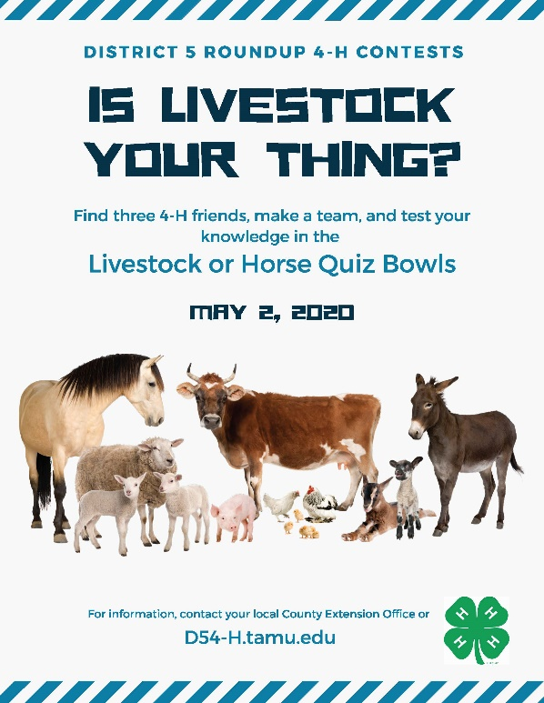
The Livestock Quiz Bowl is an exciting, fast paced contest for youth to display their knowledge of the livestock industry and the science surrounding cattle, swine, sheep and goats.

Entry
- Enter as a team of 4 members.
- Teams are made up of individuals in the same age division (Junior, Intermediate or Senior).
- Each county may submit three teams per age division.
- A total of 9 team entries per county may be submitted for the district contest.

Contest Brackets
  - Teams will be randomly selected in contest brackets, based upon age division.
  - Each contest is a double elimination tournament where a total of two losses are needed to eliminate a team from further competition.

Question Types
  - The number of questions used per round will include at least eight (8) one-on-one questions, sixteen (16) toss-up questions, and two (2) to four (4) bonus questions.
    - One-on-One questions are those to which only one member or each team may respond in a head-to-head match between the acknowledged members of each team. These points will count toward individual and team scores.
    - Toss-up questions are open to response by all contestants. These points will count toward individual and team scores.
    - Bonus questions are attached to toss-up questions and are given to the team that correctly answered the toss-up question. These points count toward a team score only and do NOT count towards individual points. No more than 25% of toss-up questions will have a bonus question attached and in general will be somewhat more difficult.

Scoring
- The overall team score shall be determined by totaling the top scores of the members. Only positive scores will quality for placings 1st – 3rd.
- An individual high point award will be presented in each age division.

Electronic Devices
  - No electronic devices or jewelry (except for medically required) is allowed in contest area. This includes cell phones, smart watches, or other communication devices.

Contest Room
  - ONLY THE TEAM and ONE coach is allowed in the contest room. All others must remain in the designated waiting areas or outside the building.
  - Team coach will be seated in a designated area and may not communicate with team members during the match with the exception of their one time out.
  - Team coach will be permitted one 1-minute time out during their match to provide encouragement to contestants.
  - Teams must check-in and check-out of the contest room.

Reference Materials
- All questions used in the quiz bowl contest will come from official sources. See the study guide and list of resources used on the web at https://texas4-h.tamu.edu/quiz/

Show Rankings
  - 4-H Livestock Quiz Bowl scorecards, comments and other correspondence will be forwarded to the contestant’s county Extension office. Please allow up to three weeks for processing.

Qualifying for State Livestock Quiz Bowl Roundup
  - Senior age division contestants (grades 9-12) which place 1st – 3rd at the District-level Livestock Quiz Bowl contest will advance to state.
  - The Texas 4-H Quiz Bowl contestant paperwork is available online at https://texas4-h.tamu.edu/quiz/

Horse Quiz Bowl
The primary objective of Horse Quiz Bowl contest is to provide an opportunity for youth enrolled in 4-H to demonstrate their knowledge of equine-related subject matter in a competitive setting.

Entry
- Enter as a team of 4 members.
- Teams are made up of individuals in the same age division (Junior, Intermediate or Senior).
- Each county may submit three teams per age division.
- A total of 9 team entries per county may be submitted for the district contest.

Contest Brackets
  - Teams will be randomly selected in contest brackets, based upon age division.
  - Each contest is a double elimination tournament where a total of two losses are needed to eliminate a team from further competition.

Question Types
  - The number of questions used per round will include at least eight (8) one-on-one questions, sixteen (16) toss-up questions, and two (2) to four (4) bonus questions.
    - One-on-One questions are those to which only one member or each team may respond in a head-to-head match between the acknowledged members of each team. These points will count toward individual and team scores.
    - Toss-up questions are open to response by all contestants. These points will count toward individual and team scores.
    - Bonus questions are attached to toss-up questions and are given to the team that correctly answered the toss-up question. These points count toward a team score only and do NOT count towards individual points. No more than 25% of toss-up questions will have a bonus question attached and in general will be somewhat more difficult.

Scoring
- The overall team score shall be determined by totaling the top scores of the members. Only positive scores will quality for placings 1st – 3rd.
- An individual high point award will be presented in each age division.

Electronic Devices
  - No electronic devices or jewelry (except for medically required) is allowed in contest area. This includes cell phones, smart watches, or other communication devices.

Contest Room
  - ONLY THE TEAM and ONE coach is allowed in the contest room. All others must remain in the designated waiting areas or outside the building.
  - Team coach will be seated in a designated area and may not communicate with team members during the match with the exception of their one time out.
  - Team coach will be permitted one 1-minute time out during their match to provide encouragement to contestants.
  - Teams must check-in and check-out of the contest room.

Reference Materials
- All questions used in the quiz bowl contest will come from official sources.
- See the study guide and list of resources used on the web at http://texas4-h.tamu.edu/wp-content/uploads/Horse-Quiz-Bowl-Resources-1.pdf

Show Rankings
  - 4-H Horse Quiz Bowl scorecards, comments and other correspondence will be forwarded to the contestant’s county Extension office. Please allow up to three weeks for processing.

Qualifying for State Horse Quiz Bowl Roundup
  - Senior age division contestants (grades 9-12) which place 1st – 3rd at the District-level Horse Quiz Bowl contest will advance to state.
  - The Texas 4-H Quiz Bowl contestant paperwork is available online at
https://texas4-h.tamu.edu/quiz/

leaders 4 life
Leaders 4 Life is a competition to challenge county teams in their leadership skills, knowledge of parliamentary procedure, and service-learning activities.

Entry
- Enter as a team of 4 to 6 members.
- Teams are made up of individuals in the same age division (Junior, Intermediate or Senior).

Electronic Devices
  - No electronic devices, calculators, or jewelry (except for medically required) is allowed in contest area. This includes cell phones, smart watches, or other communication devices.

Contest
- Each team will consist of four to six members, including at a minimum the president, vice president, secretary, and treasurer. Up to two additional team members can be in any position—such as reporter or recreation leader—or just as members of the club. Officer positions are determined by the team in advance.

- The Senior Team Leaders 4 Life Skill-A-Thon has three components:
  - Parliamentary Procedure Contest—The teams will demonstrate a simulated 4-H meeting using a standard agenda that is provided at the event. Teams of four to six county 4-H council members will have 20 minutes to conduct the meeting before a panel of judges. The maximum number of points for this part of the contest is 100. The problems may incorporate any of these motions:

- Put a motion before the assembly | - Rise to a point of order
- Lay on the table | - Appeal the decision of the chair
- Amend a motion | - Previous question
- Division of the assembly | - Rescind a motion
- Take from the table | - Reconsider a motion
- Withdraw a motion | - Postpone a motion definitely
- Division of a question | - Postpone a motion indefinitely
- Refer a motion to a committee | - Object to the consideration of the question

- Each team must provide its own minutes, treasurer’s report, letter of communication, and committee report. Prepared scripts are not allowed. Contest officials will check these materials before the team enters the planning room and collect them at the end of its presentation.
- Before the demonstration, each team will have 15 minutes to discuss the order of business and the problems of new business with fellow teammates in the planning room. No coaches, parents, agents, or other 4-H members not part of the team will be allowed in the planning room. Contestants may make notes on their agendas during the planning time
- Use of the gavel: The gavel is a symbol of authority. It is used by the president to maintain order and keep the meeting running smoothly.

  - Question-and-Answer Session—Each team will be asked 10 questions on parliamentary procedure. Every team member must answer at least one question but no more than three questions. The remaining questions may be answered by any team member, and the team members will choose who will answer the extra questions before they are read. Each contestant must begin a response within 10 seconds and complete the answer within 1 minute. Each question is worth up to 10 points, for a maximum score of 100 points.

  - Service Learning Interview—Each team will submit a simple document (not judged) that includes the name of a project that was conducted during the year. The document will include the project name and three or four sentences describing it. The judges will ask the team about the project and its use of the eight steps of service learning (outlined on page 6 of the Use Your Hands ... For Service document). The maximum score is 70 points.

- The teams will present a simulated 4-H meeting no longer than 20 minutes. Five points will be deducted from the average score for every minute over the 20-minute limit. That is, meetings over 20 minutes will get a five-point deduction; over 21 minutes a 10-point deduction, over 22 minutes a 15-point deduction, and so on. The deductions will be handled in tabulation. The timekeeper will keep track of the length of presentations and provide the information for tabulation.
- The teams will be given three problems to incorporate into the demonstration. A skeleton agenda will also be provided. The teams must demonstrate all actions on the score sheet. They must incorporate six motions into their demonstration: main motion, amend a motion, division of the assembly, lay on the table, take from the table, and withdraw a motion.

- Contest Components for Intermediate Teams: The following modifications will be made for intermediate teams for the Leaders 4 Life Skill-A-Thon. All other contest rules above will be followed.
- Parliamentary Procedure Contest—Each team will demonstrate a simulated 4-H meeting using a standard agenda that is provided at the event. Teams of four to six junior members will have 15 minutes to conduct the meeting before a panel of judges. All other contest rules will remain, except for these changes for the intermediate division (100 points):
o Only two types of motions must be demonstrated: main motion and amend a motion.
o The team will be given one problem to incorporate into its presentation. The problem will be based on one of these motions: Division of the assembly, lay on the table, take from the table, withdraw a motion.

- Question-and-Answer Session—Each intermediate team will be asked seven questions. Every team member must answer at least one question but no more than two questions. The team members will answer in this order: president, vice president, secretary, treasurer, member, and member. The remaining questions may be answered by any team member, and the team will choose who will answer each question before it is read. Each question is worth up to 10 points, for a maximum score of 70 points.
o The questions will be based on these documents: Dunbar’s Meeting Procedure Guide, Dunbar’s Guide For Making Motions, and Dunbar’s Parliamentary Procedure Glossary.

- Promote 4-H Showcase Piece—Each team will develop a tool to promote 4-H. The 4-H clover must be used on the showcase piece according to the guidelines in Use of the 4-H Name and Emblem. These items can be used for the Promote 4-H Showcase Piece:
o Banner
o Tabletop or tri-fold exhibit
o PowerPoint presentation
o Scrapbook
o Brochure
o Website

- The team must also complete and turn in (see the Leaders 4 Life Score Sheets and Forms Packet) a Promote 4-H Showcase Piece and Form to explain when and how the showcase piece was used to promote 4-H, the number of people reached, and the number of new 4-H members enrolled as a result of the 4-H promotion (50 points).

- Contest Components for Junior Teams: The following modifications will be made for junior teams for the Leaders 4 Life Skill-A-Thon. All other contest rules above will be followed.
- Parliamentary Procedure Contest—The teams will demonstrate a simulated 4-H meeting using a standard agenda that is provided at the event. Teams of four to six junior members will have 10 minutes to conduct the meeting before a panel of judges. All other contest rules will remain, except for these changes for the junior division (100 points):
    - Only two types of motions must be demonstrated: main motion and amend a motion.

- No problems will be given to the team to incorporate into its presentation.

- Promote 4-H Showcase Piece—Each team will develop a tool to promote 4-H. The 4-H clover must be used on the showcase piece according to the guidelines in Use of the 4-H Name and Emblem. The Promote 4-H Showcase Piece may use any of these items:
o Banner
o Tabletop or tri-fold exhibit
o PowerPoint presentation
o Scrapbook
o Brochure
o Website
- The team must also complete and turn in the Promote 4-H Showcase Piece and a Promote 4-H Showcase Form (Forms and Scoresheets Packet) to explain when and how the piece was used to promote 4-H, the number of people reached, and the number of new 4-H members enrolled as a result of the 4-H promotion (50 points).
Study Guide: You will find a list of resources and study guide to download on the 4-H website at https://texas4-h.tamu.edu/projects/leadership/
Qualifying for State Leaders-4-Life Roundup
  - Senior age division contestants (grades 9-12) which place 1st – 3rd at the District-level Leaders-4-Life contest will advance to state.
  - The Texas 4-H Roundup contestant paperwork is available online at
https://texas4-h.tamu.edu/quiz/

